SAM(Serverless Application Model) with Code Deploy

**Serverless Application Model(SAM) to BlueGreen Deployment to LambdaFunction Versions & Alias using CodeDeploy. (when new code changes)**

Download SAM.zip file using below link. Or you can run “sam init --runtime python3.7” in cloudshell to clone

<https://github.com/kohlidevops/aws-sam-codedeploy/blob/main/SAM.zip>

//I just worked from AWS Cloud Shell. I just run sam init to clone new sam app.

$sam init –python3.7

Which template source would you like to use? – AWS Quick Start Templates

Choose a AWS Quick Start Application – Hello World Example

Would you like to enable XRAY – N

Would you like to enable CloudWatch Insights – N

Project name – sam-app

$cd sam-app

$sam build

$vi template.yaml -> Add below line

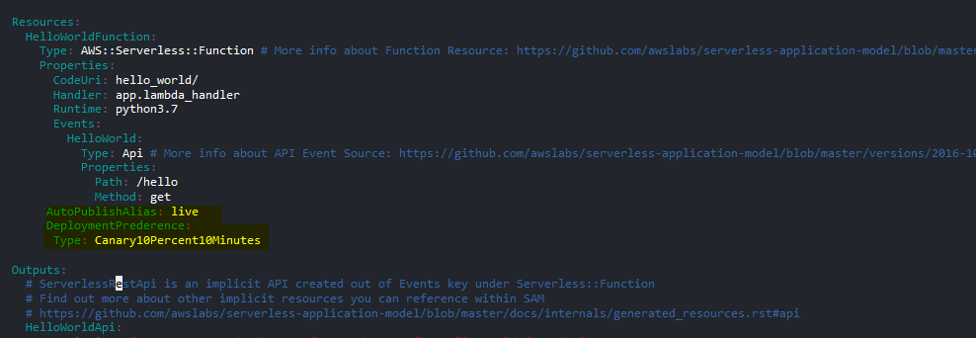

AutoPublishAlias: live

DeploymentPreference:

Type: Canary10Percent10Minutes

Then save this file (:wq!)

Then rebuild again with updated file

$sam build

Build was succeeded.

//If you are facing any issue with template.yaml, then kindly download the zip file then unzip it. You can find the updated template.yaml file. Then just copy this file to sam-app

$sam deploy –guided

Settings

Stack Name [sam-app]: enter

AWS Region [ap-south-1]: enter

#Shows you resources changes to be deployed and require a 'Y' to initiate deploy

Confirm changes before deploy [y/N]: y

#SAM needs permission to be able to create roles to connect to the resources in your template

Allow SAM CLI IAM role creation [Y/n]: Y

#Preserves the state of previously provisioned resources when an operation fails

Disable rollback [y/N]: y

HelloWorldFunction may not have authorization defined, Is this okay? [y/N]: y

Save arguments to configuration file [Y/n]: Y

SAM configuration file [samconfig.toml]: enter

SAM configuration environment [default]: enter

Deploy this changes? Y

Successfully created. Lambda has been created for sam-app

Here its my lambda function

Latest version has been deployed

Alias has weighted 100 percent

If you select “live Alias” then test this code

Then change the content to app.py in sam-app. Back to CloudShell and edit the app.py

$cd sam-app

$cd hello_world

$vi app.py

I’m going to change the content “hello world” to “hello latchu” and save this file

$cd ..

//make ensure your current working directory sam-app

$sam build

Yes, Build is succeeded

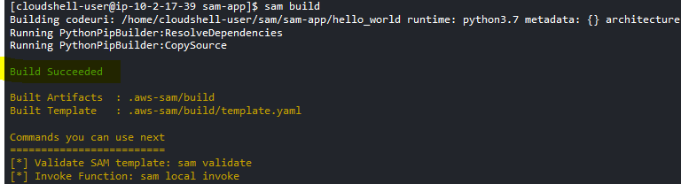

$sam deploy –-guided

Deploy this changeset? Y

You can see version 1 & 2 with weighted policy (that’s Blue green Deployment)

So 90 percent request has been redirect to version-1

Whereas 10 percent request has been redirect to version-2, that is recently built and deployed

You can see the Blue Green deployment through Code Deploy

After some times, 100 percent request has been redirect to Replacement – which is version-2

Here we go, 100 percent request has been redirect to Version-2

Have a look at the Lambda Version Weight percent

Version-2 is mapped

Finally completely version-2 is mapped to Lambda Alias

That’s it.